**Explore Weather Trends**

The first project aiming to extract, manipulate and using weather data, comparing the global temperature with the big nearest city one. For this reason I choose Milan, Italy.

So I started it using Udacity SQL addon, typing the right query to extract and download the interested data (Global and Milan too):

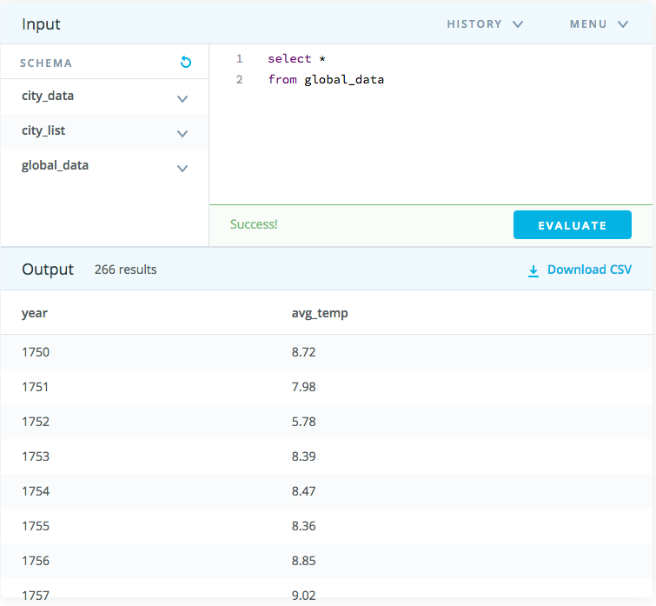

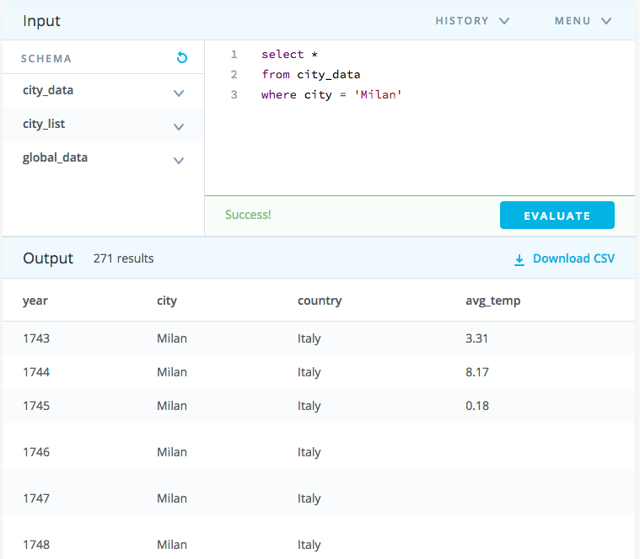

Downloaded the necessary data I manipulated it using Microsoft Excel, creating firstly a table composed by 4 main columns (Global temperature, Milan temperature, Global average temperature, Milan average temperature) and then plotting 2 different line charts: 1st comparing the overall and 2nd the average temperatures. To fill averages columns in I needed to structure the AVERAGE formula: ${\frac{1}{n}*\sum_{i=1}^{n}{x}}_{i}$ where n indicate the terms number and x is our variable.

Set it up I could create the table below:

|  |  |  |  |  |  |
| --- | --- | --- | --- | --- | --- |
| **GLOBAL** | | **MILAN** | | **GLOBAL AVARAGE TEMP** | **MILAN AVARAGE TEMP** |
| **year** | **temp** | **year** | **temp** |
| 1750 | 8.72 | 1750 | 7.51 | \ | \ |
| 1751 | 7.98 | 1751 | 7.77 | 8.35 | 7.64 |
| 1752 | 5.78 | 1752 | 2.65 | 6.88 | 5.21 |
| 1753 | 8.39 | 1753 | 6.83 | 7.085 | 4.74 |
| 1754 | 8.47 | 1754 | 6.53 | 8.43 | 6.68 |
| 1755 | 8.36 | 1755 | 6.27 | 8.415 | 6.4 |
| 1756 | 8.85 | 1756 | 6.61 | 8.605 | 6.44 |
| 1757 | 9.02 | 1757 | 6.3 | 8.935 | 6.455 |
| 1758 | 6.74 | 1758 | 5.97 | 7.88 | 6.135 |
| 1759 | 7.99 | 1759 | 7.14 | 7.365 | 6.555 |
| 1760 | 7.19 | 1760 | 7.15 | 7.59 | 7.145 |
| 1761 | 8.77 | 1761 | 6.99 | 7.98 | 7.07 |
| 1762 | 8.61 | 1762 | 6.69 | 8.69 | 6.84 |
| 1763 | 7.5 | 1763 | 6.48 | 8.055 | 6.585 |
| 1764 | 8.4 | 1764 | 6.93 | 7.95 | 6.705 |
| 1765 | 8.25 | 1765 | 6.73 | 8.325 | 6.83 |
| 1766 | 8.41 | 1766 | 6.54 | 8.33 | 6.635 |
| 1767 | 8.22 | 1767 | 6.15 | 8.315 | 6.345 |
| 1768 | 6.78 | 1768 | 6.23 | 7.5 | 6.19 |
| 1769 | 7.69 | 1769 | 6.67 | 7.235 | 6.45 |
| 1770 | 7.69 | 1770 | 6.56 | 7.69 | 6.615 |
| 1771 | 7.85 | 1771 | 6.79 | 7.77 | 6.675 |
| 1772 | 8.19 | 1772 | 8.13 | 8.02 | 7.46 |
| 1773 | 8.22 | 1773 | 6.65 | 8.205 | 7.39 |
| 1774 | 8.77 | 1774 | 6.57 | 8.495 | 6.61 |
| 1775 | 9.18 | 1775 | 7.18 | 8.975 | 6.875 |
| 1776 | 8.3 | 1776 | 6.62 | 8.74 | 6.9 |
| 1777 | 8.26 | 1777 | 6.33 | 8.28 | 6.475 |
| 1778 | 8.54 | 1778 | 7.16 | 8.4 | 6.745 |
| 1779 | 8.98 | 1779 | 7.55 | 8.76 | 7.355 |
| 1780 | 9.43 | 1780 | 7.09 | 9.205 | 7.32 |
| 1781 | 8.1 | 1781 | 7.57 | 8.765 | 7.33 |
| 1782 | 7.9 | 1782 | 6.11 | 8 | 6.84 |
| 1783 | 7.68 | 1783 | 7.27 | 7.79 | 6.69 |
| 1784 | 7.86 | 1784 | 6.26 | 7.77 | 6.765 |
| 1785 | 7.36 | 1785 | 6.26 | 7.61 | 6.26 |
| 1786 | 8.26 | 1786 | 6.34 | 7.81 | 6.3 |
| 1787 | 8.03 | 1787 | 7.05 | 8.145 | 6.695 |
| 1788 | 8.45 | 1788 | 7.24 | 8.24 | 7.145 |
| 1789 | 8.33 | 1789 | 6.28 | 8.39 | 6.76 |
| 1790 | 7.98 | 1790 | 7.15 | 8.155 | 6.715 |
| 1791 | 8.23 | 1791 | 7.3 | 8.105 | 7.225 |
| 1792 | 8.09 | 1792 | 6.91 | 8.16 | 7.105 |
| 1793 | 8.23 | 1793 | 7.08 | 8.16 | 6.995 |
| 1794 | 8.53 | 1794 | 7.57 | 8.38 | 7.325 |
| 1795 | 8.35 | 1795 | 6.53 | 8.44 | 7.05 |
| 1796 | 8.27 | 1796 | 6.79 | 8.31 | 6.66 |
| 1797 | 8.51 | 1797 | 7.18 | 8.39 | 6.985 |
| 1798 | 8.67 | 1798 | 6.88 | 8.59 | 7.03 |
| 1799 | 8.51 | 1799 | 5.65 | 8.59 | 6.265 |
| 1800 | 8.48 | 1800 | 7.17 | 8.495 | 6.41 |
| 1801 | 8.59 | 1801 | 7.21 | 8.535 | 7.19 |
| 1802 | 8.58 | 1802 | 7.53 | 8.585 | 7.37 |
| 1803 | 8.5 | 1803 | 6.62 | 8.54 | 7.075 |
| 1804 | 8.84 | 1804 | 7.08 | 8.67 | 6.85 |
| 1805 | 8.56 | 1805 | 5.5 | 8.7 | 6.29 |
| 1806 | 8.43 | 1806 | 7.2 | 8.495 | 6.35 |
| 1807 | 8.28 | 1807 | 6.95 | 8.355 | 7.075 |
| 1808 | 7.63 | 1808 | 5.57 | 7.955 | 6.26 |
| 1809 | 7.08 | 1809 | 6.36 | 7.355 | 5.965 |
| 1810 | 6.92 | 1810 | 6.59 | 7 | 6.475 |
| 1811 | 6.86 | 1811 | 7.59 | 6.89 | 7.09 |
| 1812 | 7.05 | 1812 | 5.42 | 6.955 | 6.505 |
| 1813 | 7.74 | 1813 | 6.27 | 7.395 | 5.845 |
| 1814 | 7.59 | 1814 | 5.57 | 7.665 | 5.92 |
| 1815 | 7.24 | 1815 | 6.45 | 7.415 | 6.01 |
| 1816 | 6.94 | 1816 | 5.2 | 7.09 | 5.825 |
| 1817 | 6.98 | 1817 | 6.51 | 6.96 | 5.855 |
| 1818 | 7.83 | 1818 | 6.95 | 7.405 | 6.73 |
| 1819 | 7.37 | 1819 | 7 | 7.6 | 6.975 |
| 1820 | 7.62 | 1820 | 6.36 | 7.495 | 6.68 |
| 1821 | 8.09 | 1821 | 6.65 | 7.855 | 6.505 |
| 1822 | 8.19 | 1822 | 8.01 | 8.14 | 7.33 |
| 1823 | 7.72 | 1823 | 6.31 | 7.955 | 7.16 |
| 1824 | 8.55 | 1824 | 6.97 | 8.135 | 6.64 |
| 1825 | 8.39 | 1825 | 7.28 | 8.47 | 7.125 |
| 1826 | 8.36 | 1826 | 6.78 | 8.375 | 7.03 |
| 1827 | 8.81 | 1827 | 6.54 | 8.585 | 6.66 |
| 1828 | 8.17 | 1828 | 7.43 | 8.49 | 6.985 |
| 1829 | 7.94 | 1829 | 5.44 | 8.055 | 6.435 |
| 1830 | 8.52 | 1830 | 6.39 | 8.23 | 5.915 |
| 1831 | 7.64 | 1831 | 6.83 | 8.08 | 6.61 |
| 1832 | 7.45 | 1832 | 6.51 | 7.545 | 6.67 |
| 1833 | 8.01 | 1833 | 6.77 | 7.73 | 6.64 |
| 1834 | 8.15 | 1834 | 7.59 | 8.08 | 7.18 |
| 1835 | 7.39 | 1835 | 6.18 | 7.77 | 6.885 |
| 1836 | 7.7 | 1836 | 6.15 | 7.545 | 6.165 |
| 1837 | 7.38 | 1837 | 5.81 | 7.54 | 5.98 |
| 1838 | 7.51 | 1838 | 5.72 | 7.445 | 5.765 |
| 1839 | 7.63 | 1839 | 6.85 | 7.57 | 6.285 |
| 1840 | 7.8 | 1840 | 6.19 | 7.715 | 6.52 |
| 1841 | 7.69 | 1841 | 6.87 | 7.745 | 6.53 |
| 1842 | 8.02 | 1842 | 6.19 | 7.855 | 6.53 |
| 1843 | 8.17 | 1843 | 6.44 | 8.095 | 6.315 |
| 1844 | 7.65 | 1844 | 6.38 | 7.91 | 6.41 |
| 1845 | 7.85 | 1845 | 6.19 | 7.75 | 6.285 |
| 1846 | 8.55 | 1846 | 7.46 | 8.2 | 6.825 |
| 1847 | 8.09 | 1847 | 6.24 | 8.32 | 6.85 |
| 1848 | 7.98 | 1848 | 6.46 | 8.035 | 6.35 |
| 1849 | 7.98 | 1849 | 6.77 | 7.98 | 6.615 |
| 1850 | 7.9 | 1850 | 5.88 | 7.94 | 6.325 |
| 1851 | 8.18 | 1851 | 5.85 | 8.04 | 5.865 |
| 1852 | 8.1 | 1852 | 6.81 | 8.14 | 6.33 |
| 1853 | 8.04 | 1853 | 5.79 | 8.07 | 6.3 |
| 1854 | 8.21 | 1854 | 6.36 | 8.125 | 6.075 |
| 1855 | 8.11 | 1855 | 5.68 | 8.16 | 6.02 |
| 1856 | 8 | 1856 | 6.52 | 8.055 | 6.1 |
| 1857 | 7.76 | 1857 | 6.53 | 7.88 | 6.525 |
| 1858 | 8.1 | 1858 | 5.78 | 7.93 | 6.155 |
| 1859 | 8.25 | 1859 | 7 | 8.175 | 6.39 |
| 1860 | 7.96 | 1860 | 5.38 | 8.105 | 6.19 |
| 1861 | 7.85 | 1861 | 6.81 | 7.905 | 6.095 |
| 1862 | 7.56 | 1862 | 7.28 | 7.705 | 7.045 |
| 1863 | 8.11 | 1863 | 7.32 | 7.835 | 7.3 |
| 1864 | 7.98 | 1864 | 5.99 | 8.045 | 6.655 |
| 1865 | 8.18 | 1865 | 6.99 | 8.08 | 6.49 |
| 1866 | 8.29 | 1866 | 7.05 | 8.235 | 7.02 |
| 1867 | 8.44 | 1867 | 6.8 | 8.365 | 6.925 |
| 1868 | 8.25 | 1868 | 7.21 | 8.345 | 7.005 |
| 1869 | 8.43 | 1869 | 6.61 | 8.34 | 6.91 |
| 1870 | 8.2 | 1870 | 6.19 | 8.315 | 6.4 |
| 1871 | 8.12 | 1871 | 5.98 | 8.16 | 6.085 |
| 1872 | 8.19 | 1872 | 7.14 | 8.155 | 6.56 |
| 1873 | 8.35 | 1873 | 7.13 | 8.27 | 7.135 |
| 1874 | 8.43 | 1874 | 6.52 | 8.39 | 6.825 |
| 1875 | 7.86 | 1875 | 6.45 | 8.145 | 6.485 |
| 1876 | 8.08 | 1876 | 6.65 | 7.97 | 6.55 |
| 1877 | 8.54 | 1877 | 6.79 | 8.31 | 6.72 |
| 1878 | 8.83 | 1878 | 6.42 | 8.685 | 6.605 |
| 1879 | 8.17 | 1879 | 5.91 | 8.5 | 6.165 |
| 1880 | 8.12 | 1880 | 6.97 | 8.145 | 6.44 |
| 1881 | 8.27 | 1881 | 6.47 | 8.195 | 6.72 |
| 1882 | 8.13 | 1882 | 6.78 | 8.2 | 6.625 |
| 1883 | 7.98 | 1883 | 6.05 | 8.055 | 6.415 |
| 1884 | 7.77 | 1884 | 6.59 | 7.875 | 6.32 |
| 1885 | 7.92 | 1885 | 6.56 | 7.845 | 6.575 |
| 1886 | 7.95 | 1886 | 6.55 | 7.935 | 6.555 |
| 1887 | 7.91 | 1887 | 5.64 | 7.93 | 6.095 |
| 1888 | 8.09 | 1888 | 5.79 | 8 | 5.715 |
| 1889 | 8.32 | 1889 | 5.81 | 8.205 | 5.8 |
| 1890 | 7.97 | 1890 | 5.92 | 8.145 | 5.865 |
| 1891 | 8.02 | 1891 | 5.92 | 7.995 | 5.92 |
| 1892 | 8.07 | 1892 | 6.5 | 8.045 | 6.21 |
| 1893 | 8.06 | 1893 | 6.82 | 8.065 | 6.66 |
| 1894 | 8.16 | 1894 | 6.69 | 8.11 | 6.755 |
| 1895 | 8.15 | 1895 | 6.19 | 8.155 | 6.44 |
| 1896 | 8.21 | 1896 | 5.97 | 8.18 | 6.08 |
| 1897 | 8.29 | 1897 | 7.04 | 8.25 | 6.505 |
| 1898 | 8.18 | 1898 | 7.36 | 8.235 | 7.2 |
| 1899 | 8.4 | 1899 | 7.24 | 8.29 | 7.3 |
| 1900 | 8.5 | 1900 | 7.13 | 8.45 | 7.185 |
| 1901 | 8.54 | 1901 | 6.04 | 8.52 | 6.585 |
| 1902 | 8.3 | 1902 | 6.52 | 8.42 | 6.28 |
| 1903 | 8.22 | 1903 | 6.55 | 8.26 | 6.535 |
| 1904 | 8.09 | 1904 | 7.27 | 8.155 | 6.91 |
| 1905 | 8.23 | 1905 | 6.27 | 8.16 | 6.77 |
| 1906 | 8.38 | 1906 | 6.72 | 8.305 | 6.495 |
| 1907 | 7.95 | 1907 | 6.68 | 8.165 | 6.7 |
| 1908 | 8.19 | 1908 | 6.52 | 8.07 | 6.6 |
| 1909 | 8.18 | 1909 | 6.12 | 8.185 | 6.32 |
| 1910 | 8.22 | 1910 | 6.42 | 8.2 | 6.27 |
| 1911 | 8.18 | 1911 | 7.28 | 8.2 | 6.85 |
| 1912 | 8.17 | 1912 | 6.22 | 8.175 | 6.75 |
| 1913 | 8.3 | 1913 | 6.67 | 8.235 | 6.445 |
| 1914 | 8.59 | 1914 | 6.55 | 8.445 | 6.61 |
| 1915 | 8.59 | 1915 | 6.3 | 8.59 | 6.425 |
| 1916 | 8.23 | 1916 | 6.64 | 8.41 | 6.47 |
| 1917 | 8.02 | 1917 | 5.97 | 8.125 | 6.305 |
| 1918 | 8.13 | 1918 | 6.58 | 8.075 | 6.275 |
| 1919 | 8.38 | 1919 | 6.2 | 8.255 | 6.39 |
| 1920 | 8.36 | 1920 | 7.46 | 8.37 | 6.83 |
| 1921 | 8.57 | 1921 | 7.61 | 8.465 | 7.535 |
| 1922 | 8.41 | 1922 | 6.38 | 8.49 | 6.995 |
| 1923 | 8.42 | 1923 | 7.1 | 8.415 | 6.74 |
| 1924 | 8.51 | 1924 | 6.69 | 8.465 | 6.895 |
| 1925 | 8.53 | 1925 | 6.51 | 8.52 | 6.6 |
| 1926 | 8.73 | 1926 | 7.18 | 8.63 | 6.845 |
| 1927 | 8.52 | 1927 | 7.18 | 8.625 | 7.18 |
| 1928 | 8.63 | 1928 | 7.32 | 8.575 | 7.25 |
| 1929 | 8.24 | 1929 | 6.61 | 8.435 | 6.965 |
| 1930 | 8.63 | 1930 | 7.17 | 8.435 | 6.89 |
| 1931 | 8.72 | 1931 | 6.39 | 8.675 | 6.78 |
| 1932 | 8.71 | 1932 | 6.58 | 8.715 | 6.485 |
| 1933 | 8.34 | 1933 | 6.4 | 8.525 | 6.49 |
| 1934 | 8.63 | 1934 | 7.47 | 8.485 | 6.935 |
| 1935 | 8.52 | 1935 | 6.71 | 8.575 | 7.09 |
| 1936 | 8.55 | 1936 | 6.92 | 8.535 | 6.815 |
| 1937 | 8.7 | 1937 | 7.07 | 8.625 | 6.995 |
| 1938 | 8.86 | 1938 | 6.94 | 8.78 | 7.005 |
| 1939 | 8.76 | 1939 | 6.5 | 8.81 | 6.72 |
| 1940 | 8.76 | 1940 | 5.95 | 8.76 | 6.225 |
| 1941 | 8.77 | 1941 | 6.01 | 8.765 | 5.98 |
| 1942 | 8.73 | 1942 | 6.84 | 8.75 | 6.425 |
| 1943 | 8.76 | 1943 | 7.77 | 8.745 | 7.305 |
| 1944 | 8.85 | 1944 | 6.54 | 8.805 | 7.155 |
| 1945 | 8.58 | 1945 | 7.55 | 8.715 | 7.045 |
| 1946 | 8.68 | 1946 | 7.18 | 8.63 | 7.365 |
| 1947 | 8.8 | 1947 | 7.68 | 8.74 | 7.43 |
| 1948 | 8.75 | 1948 | 7.55 | 8.775 | 7.615 |
| 1949 | 8.59 | 1949 | 7.83 | 8.67 | 7.69 |
| 1950 | 8.37 | 1950 | 7.63 | 8.48 | 7.73 |
| 1951 | 8.63 | 1951 | 7.1 | 8.5 | 7.365 |
| 1952 | 8.64 | 1952 | 6.94 | 8.635 | 7.02 |
| 1953 | 8.87 | 1953 | 7.41 | 8.755 | 7.175 |
| 1954 | 8.56 | 1954 | 6.52 | 8.715 | 6.965 |
| 1955 | 8.63 | 1955 | 6.99 | 8.595 | 6.755 |
| 1956 | 8.28 | 1956 | 5.88 | 8.455 | 6.435 |
| 1957 | 8.73 | 1957 | 7.14 | 8.505 | 6.51 |
| 1958 | 8.77 | 1958 | 7.21 | 8.75 | 7.175 |
| 1959 | 8.73 | 1959 | 7.61 | 8.75 | 7.41 |
| 1960 | 8.58 | 1960 | 6.87 | 8.655 | 7.24 |
| 1961 | 8.8 | 1961 | 7.9 | 8.69 | 7.385 |
| 1962 | 8.75 | 1962 | 6.57 | 8.775 | 7.235 |
| 1963 | 8.86 | 1963 | 6.27 | 8.805 | 6.42 |
| 1964 | 8.41 | 1964 | 7.31 | 8.635 | 6.79 |
| 1965 | 8.53 | 1965 | 6.32 | 8.47 | 6.815 |
| 1966 | 8.6 | 1966 | 7.18 | 8.565 | 6.75 |
| 1967 | 8.7 | 1967 | 7.26 | 8.65 | 7.22 |
| 1968 | 8.52 | 1968 | 6.89 | 8.61 | 7.075 |
| 1969 | 8.6 | 1969 | 6.55 | 8.56 | 6.72 |
| 1970 | 8.7 | 1970 | 6.63 | 8.65 | 6.59 |
| 1971 | 8.6 | 1971 | 7.15 | 8.65 | 6.89 |
| 1972 | 8.5 | 1972 | 6.73 | 8.55 | 6.94 |
| 1973 | 8.95 | 1973 | 6.91 | 8.725 | 6.82 |
| 1974 | 8.47 | 1974 | 7.14 | 8.71 | 7.025 |
| 1975 | 8.74 | 1975 | 7.26 | 8.605 | 7.2 |
| 1976 | 8.35 | 1976 | 7.08 | 8.545 | 7.17 |
| 1977 | 8.85 | 1977 | 6.85 | 8.6 | 6.965 |
| 1978 | 8.69 | 1978 | 6.43 | 8.77 | 6.64 |
| 1979 | 8.73 | 1979 | 6.87 | 8.71 | 6.65 |
| 1980 | 8.98 | 1980 | 6.43 | 8.855 | 6.65 |
| 1981 | 9.17 | 1981 | 6.95 | 9.075 | 6.69 |
| 1982 | 8.64 | 1982 | 7.49 | 8.905 | 7.22 |
| 1983 | 9.03 | 1983 | 7.49 | 8.835 | 7.49 |
| 1984 | 8.69 | 1984 | 6.49 | 8.86 | 6.99 |
| 1985 | 8.66 | 1985 | 6.87 | 8.675 | 6.68 |
| 1986 | 8.83 | 1986 | 7.12 | 8.745 | 6.995 |
| 1987 | 8.99 | 1987 | 7.19 | 8.91 | 7.155 |
| 1988 | 9.2 | 1988 | 7.65 | 9.095 | 7.42 |
| 1989 | 8.92 | 1989 | 7.86 | 9.06 | 7.755 |
| 1990 | 9.23 | 1990 | 7.97 | 9.075 | 7.915 |
| 1991 | 9.18 | 1991 | 7.28 | 9.205 | 7.625 |
| 1992 | 8.84 | 1992 | 7.76 | 9.01 | 7.52 |
| 1993 | 8.87 | 1993 | 7.43 | 8.855 | 7.595 |
| 1994 | 9.04 | 1994 | 8.39 | 8.955 | 7.91 |
| 1995 | 9.35 | 1995 | 7.43 | 9.195 | 7.91 |
| 1996 | 9.04 | 1996 | 7.06 | 9.195 | 7.245 |
| 1997 | 9.2 | 1997 | 8.18 | 9.12 | 7.62 |
| 1998 | 9.52 | 1998 | 7.77 | 9.36 | 7.975 |
| 1999 | 9.29 | 1999 | 7.64 | 9.405 | 7.705 |
| 2000 | 9.2 | 2000 | 8.13 | 9.245 | 7.885 |
| 2001 | 9.41 | 2001 | 7.83 | 9.305 | 7.98 |
| 2002 | 9.57 | 2002 | 8.15 | 9.49 | 7.99 |
| 2003 | 9.53 | 2003 | 8.55 | 9.55 | 8.35 |
| 2004 | 9.32 | 2004 | 7.74 | 9.425 | 8.145 |
| 2005 | 9.7 | 2005 | 7.33 | 9.51 | 7.535 |
| 2006 | 9.53 | 2006 | 8.15 | 9.615 | 7.74 |
| 2007 | 9.73 | 2007 | 8.4 | 9.63 | 8.275 |
| 2008 | 9.43 | 2008 | 7.91 | 9.58 | 8.155 |
| 2009 | 9.51 | 2009 | 8.11 | 9.47 | 8.01 |
| 2010 | 9.7 | 2010 | 7.05 | 9.605 | 7.58 |
| 2011 | 9.52 | 2011 | 8.68 | 9.61 | 7.865 |
| 2012 | 9.51 | 2012 | 8.05 | 9.515 | 8.365 |
| 2013 | 9.61 | 2013 | 8.04 | 9.56 | 8.045 |
| 2014 | 9.57 | 2014 |  | 9.59 | 8.04 |

Using all necessary data, I could use the Excel plotting add-on to draw and view the trends, average and overall. My keys considerations were about similarities and differences involved during the trend chart, analysing so up and down trend.





Using the overall chart, I could detect some similarities and differences, selecting 4 of them:

1. Between 1750 and 1756 we can describe an abrupt temperature decline which involved both our charts, Global and Milan one;
2. Another similarity is located between 1768 and 1780 we observe a rush temperature increment followed by both variables: even if Global one settles an higher level, we could look at the same temp rise of Milan too;
3. During 1804-1820 we can notice an opposite temperature trend between the variables and particularly on 1810 where Global was decreasing too much and instead the Milan was increasing its level, reaching almost the its maximum record;
4. At last I identified a strictly and continuous temperatures upper trend which involved both our variables, indicating the possibility to get hotter than past.

Finally, I can write general considerations about the temperatures trends. First thing I would like to underline is that Milan temperature is cooler than Global one and not just during last few years, but we could analyse it keeping in consideration the whole study period. Both trend definitely have followed the same cycle and what can I suppose looking the chart is the continuous temperature increment which taking the world to get warmer, also because of greenhouse effect and global warming.